STEFANIK: QUESTIONNAIRES

QUESTIONNAIRE BULLETS

NATIONAL RIGHT TO LIFE COMMITTEE

2022

**2022: Stefanik Was Endorsed By National Right To Life Victory Fund.**

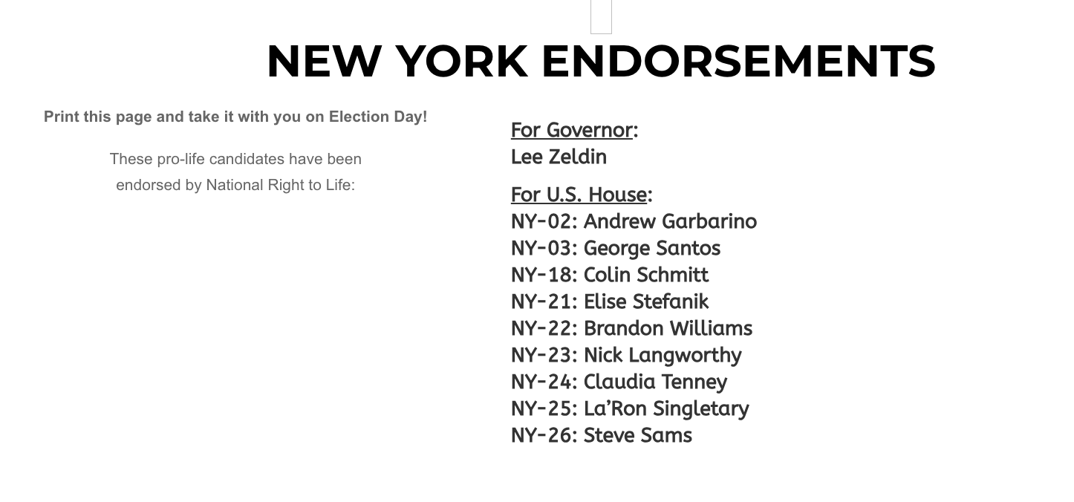

[National Right to Life Victory Fund, New York Endorsements, Archived [8/13/23](https://web.archive.org/web/20230813140605/https:/www.nrlvictoryfund.org/endorsements/newyork/)]

**2022: Angie Craig Tweeted Part Of The 2022 Congressional Candidate Questionnaire From The National Right To Life Committee.**

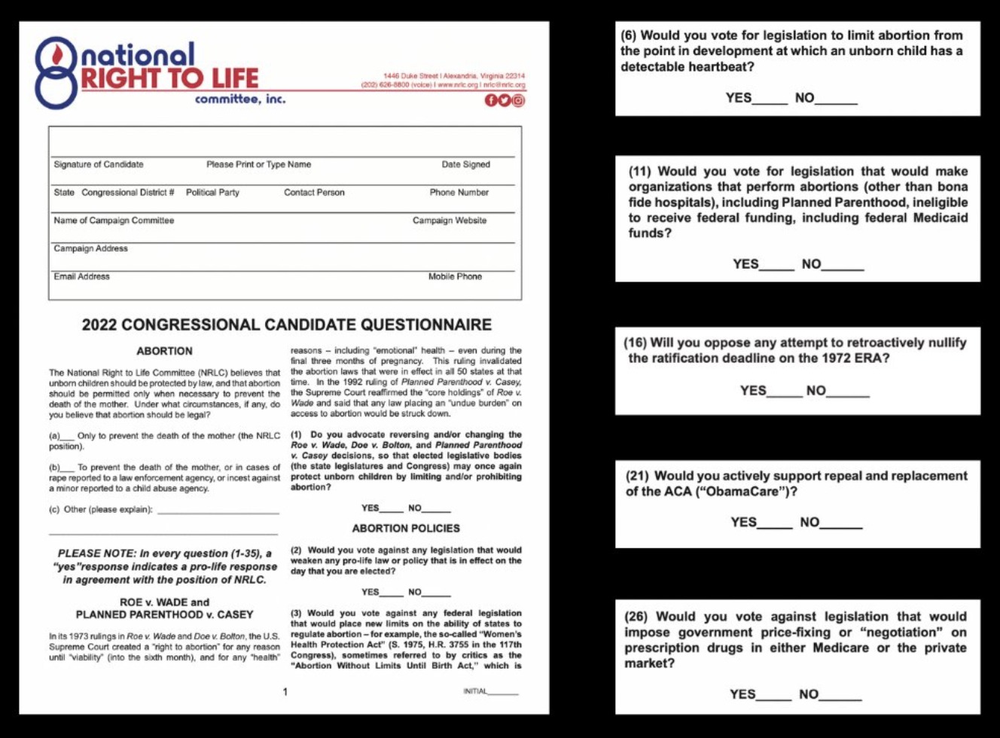

[X, @AngieCraigMN, [10/25/22](https://x.com/AngieCraigMN/status/1584936852074639360/photo/1)]

* **2022: The National Right To Life Committee Questionnaire Asked What Circumstances, If Any, Does The Candidate Believe That Abortion Should Be Legal.**



[X, @AngieCraigMN, [10/25/22](https://x.com/AngieCraigMN/status/1584936852074639360/photo/1)]

* **2022: The National Right To Life Committee Questionnaire Asked If The Candidate Advocated For Reversing Or Changing Roe V.** **Wade.**



[X, @AngieCraigMN, [10/25/22](https://x.com/AngieCraigMN/status/1584936852074639360/photo/1)]

* **2022: The National Right To Life Committee Questionnaire Asked If The Candidate Advocated For Reversing Or Changing Doe V.** **Bolton**.



[X, @AngieCraigMN, [10/25/22](https://x.com/AngieCraigMN/status/1584936852074639360/photo/1)]

* **2022: The National Right To Life Committee Questionnaire Asked If The Candidate Advocated For Reversing Or Changing Planned Parenthood V. Casey.**



[X, @AngieCraigMN, [10/25/22](https://x.com/AngieCraigMN/status/1584936852074639360/photo/1)]

* **2022: The National Right To Life Committee Questionnaire Asked If The Candidate Would Vote Against Legislation That Would Weaken Pro-Life Law.**



[X, @AngieCraigMN, [10/25/22](https://x.com/AngieCraigMN/status/1584936852074639360/photo/1)]

* **2022: The National Right To Life Committee Questionnaire Asked If The Candidate Would Vote Against Federal Legislation That Would Limit States’ Ability To Regulate Abortion.**



[X, @AngieCraigMN, [10/25/22](https://x.com/AngieCraigMN/status/1584936852074639360/photo/1)]

* **2022: The National Right To Life Committee Questionnaire Asked If The Candidate Would Vote For Legislation That Would Limit Abortion After A Detectable Heartbeat.**



[X, @AngieCraigMN, [10/25/22](https://x.com/AngieCraigMN/status/1584936852074639360/photo/1)]

* **2022: The National Right To Life Committee Questionnaire Asked If The Candidate Would Vote For Legislation That Would Make Organizations That Perform Abortion, Including Planned Parenthood Ineligible For Federal Funding And Medicaid Funds.**



[X, @AngieCraigMN, [10/25/22](https://x.com/AngieCraigMN/status/1584936852074639360/photo/1)]

* **2022: The National Right To Life Committee Questionnaire Asked If The Candidate Would Nullify The Ratification Deadline Of The 1972 ERA.**



[X, @AngieCraigMN, [10/25/22](https://x.com/AngieCraigMN/status/1584936852074639360/photo/1)]

* **2022: The National Right To Life Committee Questionnaire Asked If The Candidate Would Repeal And Replace The Aca.**



[X, @AngieCraigMN, [10/25/22](https://x.com/AngieCraigMN/status/1584936852074639360/photo/1)]

* **2022: The National Right To Life Committee Questionnaire Asked If The Candidate Would Vote Against Legislation That Would Impose Government Negotiations Of Prescription Drugs.**



[X, @AngieCraigMN, [10/25/22](https://x.com/AngieCraigMN/status/1584936852074639360/photo/1)]

2014

**2014: Stefanik Was Endorsed By National Right To Life Victory Fund.**

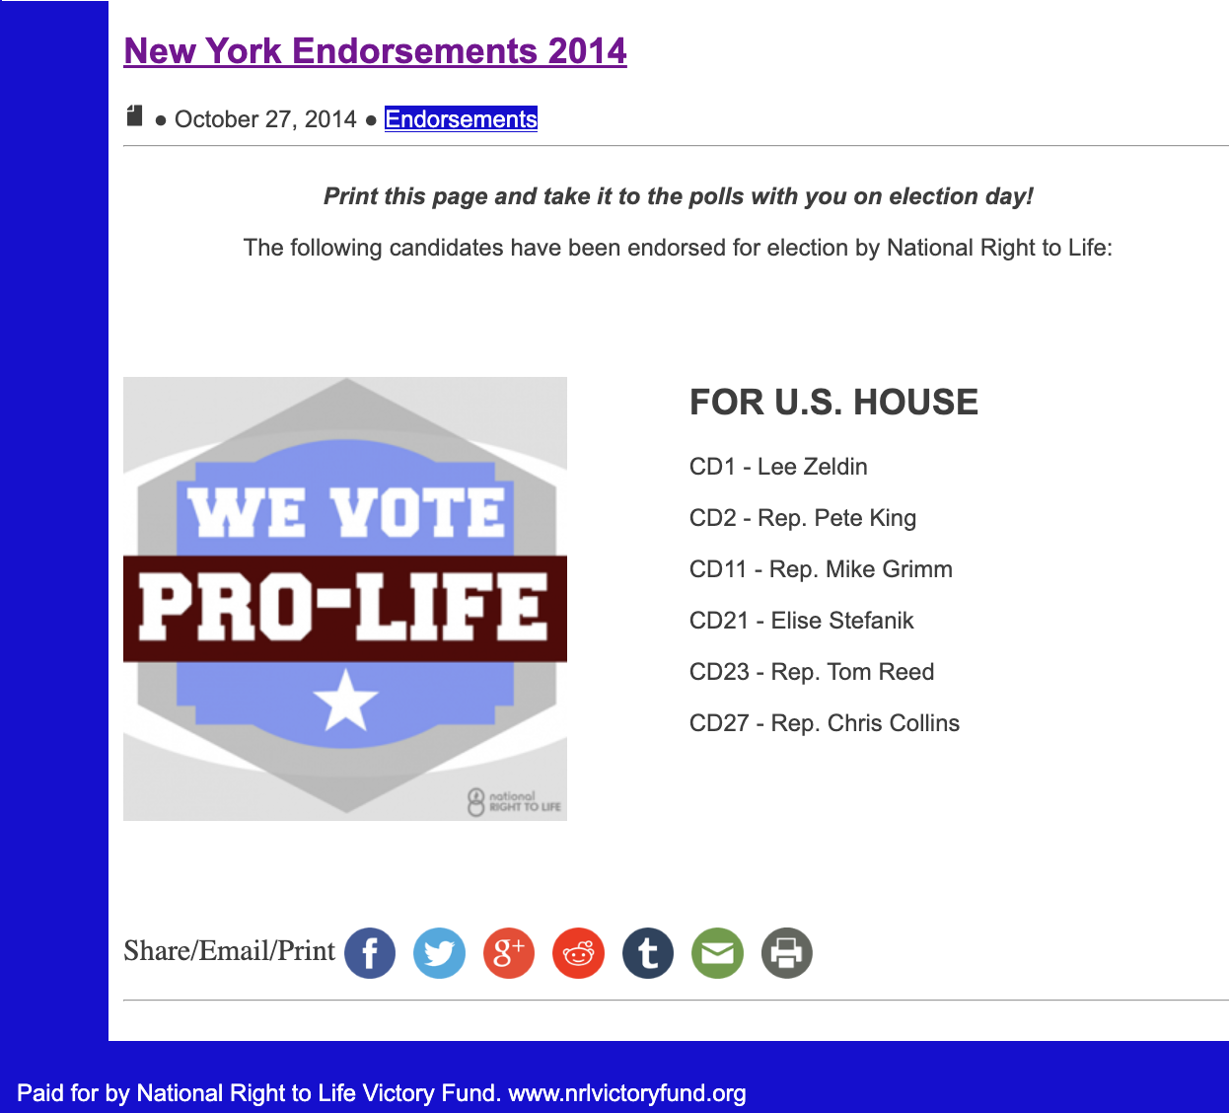

[National Right to Life Victory Fund, 2014 New York Endorsements, Archived [9/12/15](https://web.archive.org/web/20150912101051/https:/www.nrlvictoryfund.org/endorsements/newyork2014/)]

**2014: Marsha Blackburn’s Congressional Candidate Questionnaire From The National Right To Life Committee Was Posted Online.**

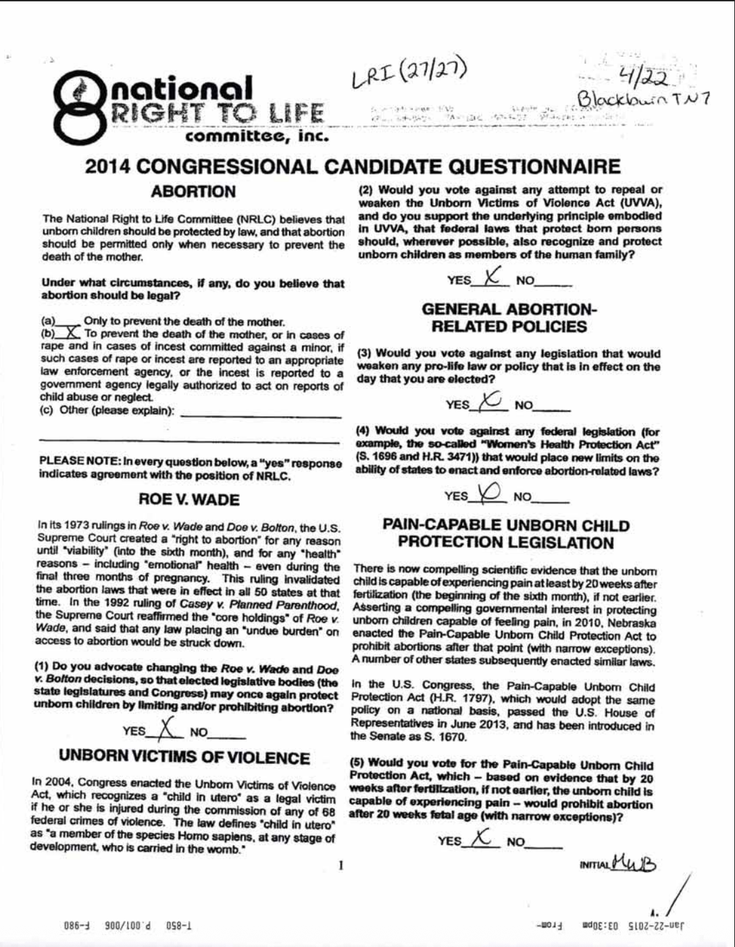

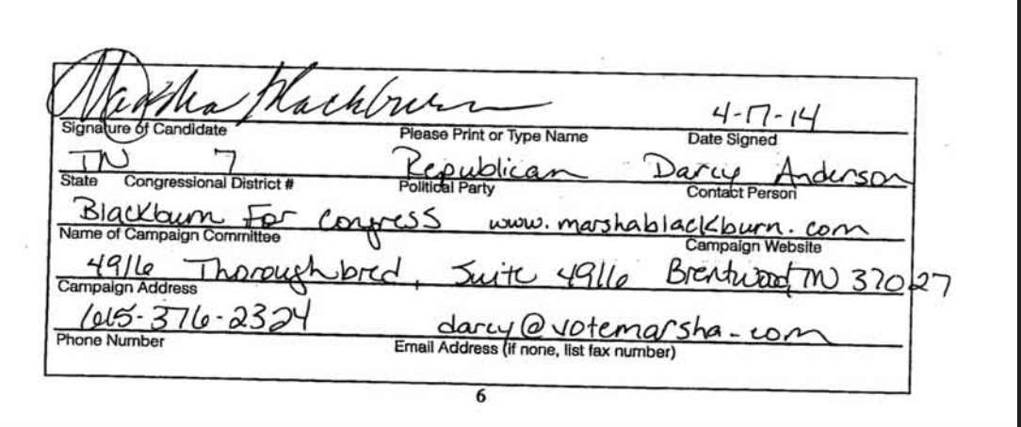

[NRLC.org, Blackburn NRLC Questionnaire 2014 (PDF), Accessed [8/21/25](https://www.nrlc.org/uploads/fedleg/BlackburnNRLCQuestionnaire2014.pdf)]

* **2014: The National Right To Life Committee’s Questionnaire Asked What Cases, If Any, Should Abortion Be Legal.**



[NRLC.org, Blackburn NRLC Questionnaire 2014 (PDF), Accessed [8/21/25](https://www.nrlc.org/uploads/fedleg/BlackburnNRLCQuestionnaire2014.pdf)]

* **2014: The National Right To Life Committee’s Questionnaire Asked If The Candidate Believed In Advocating To Change The Roe V. Wade And Doe V. Bolton Decisions.**



[NRLC.org, Blackburn NRLC Questionnaire 2014 (PDF), Accessed [8/21/25](https://www.nrlc.org/uploads/fedleg/BlackburnNRLCQuestionnaire2014.pdf)]

* **2014: The National Right To Life Committee’s Questionnaire Asked If The Candidate Would Vote Against The Repeal Of The Unborn Victims Of Violence Act.**



[NRLC.org, Blackburn NRLC Questionnaire 2014 (PDF), Accessed [8/21/25](https://www.nrlc.org/uploads/fedleg/BlackburnNRLCQuestionnaire2014.pdf)]

* **2014: The National Right To Life Committee’s Questionnaire Asked If The Candidate Would Vote Against Legislation That Would Weaken Pro-Life Laws Or Policies.**



[NRLC.org, Blackburn NRLC Questionnaire 2014 (PDF), Accessed [8/21/25](https://www.nrlc.org/uploads/fedleg/BlackburnNRLCQuestionnaire2014.pdf)]

* **2014: The National Right To Life Committee’s Questionnaire Asked If The Candidate Would Vote Against Federal Legislation That Place Limits On States Enacting Abortion-Related Laws.**



[NRLC.org, Blackburn NRLC Questionnaire 2014 (PDF), Accessed [8/21/25](https://www.nrlc.org/uploads/fedleg/BlackburnNRLCQuestionnaire2014.pdf)]

* **2014: The National Right To Life Committee’s Questionnaire Asked If** **The Candidate Would Vote Against Legislation That Would Impose A Prohibition On Abortion As A Method Of Sex Selection.**

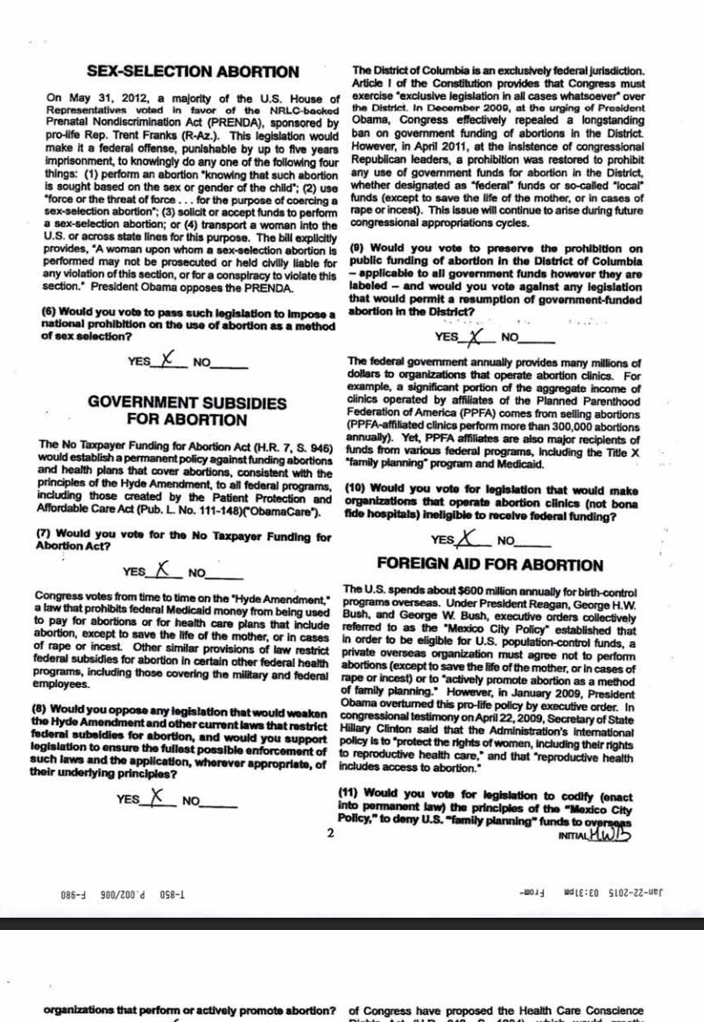

[NRLC.org, Blackburn NRLC Questionnaire 2014 (PDF), Accessed [8/21/25](https://www.nrlc.org/uploads/fedleg/BlackburnNRLCQuestionnaire2014.pdf)]

* **2014: The National Right To Life Committee’s Questionnaire Asked If** **The Candidate Would Vote For The No Taxpayer Funding For Abortion Act.**



[NRLC.org, Blackburn NRLC Questionnaire 2014 (PDF), Accessed [8/21/25](https://www.nrlc.org/uploads/fedleg/BlackburnNRLCQuestionnaire2014.pdf)]

* **2014: The National Right To Life Committee’s Questionnaire Asked If** **The Candidate Would Oppose Legislation That Would Weaken The Hyde Amendment.**



[NRLC.org, Blackburn NRLC Questionnaire 2014 (PDF), Accessed [8/21/25](https://www.nrlc.org/uploads/fedleg/BlackburnNRLCQuestionnaire2014.pdf)]

* **2014: The National Right To Life Committee’s Questionnaire Asked If** **The Candidate Would Vote To Preserve The Prohibition Of Public Funding Of Abortion In DC.**



[NRLC.org, Blackburn NRLC Questionnaire 2014 (PDF), Accessed [8/21/25](https://www.nrlc.org/uploads/fedleg/BlackburnNRLCQuestionnaire2014.pdf)]

* **2014: The National Right To Life Committee’s Questionnaire Asked If** **The Candidate Would Vote For Legislation That Would Make Organization That Operate Abortion Clinics Ineligible For Federal Funding.**



[NRLC.org, Blackburn NRLC Questionnaire 2014 (PDF), Accessed [8/21/25](https://www.nrlc.org/uploads/fedleg/BlackburnNRLCQuestionnaire2014.pdf)]

* **2014: The National Right To Life Committee’s Questionnaire Asked If** **The Candidate Would Vote For Legislation To Deny Family Planning Funds To Overseas Organization.**



[NRLC.org, Blackburn NRLC Questionnaire 2014 (PDF), Accessed [8/21/25](https://www.nrlc.org/uploads/fedleg/BlackburnNRLCQuestionnaire2014.pdf)]

* **2014: The National Right To Life Committee’s Questionnaire Asked If The Candidate Would Vote For Legislation That Would Prevent Further Funding Of The United Nations Population Fund.**

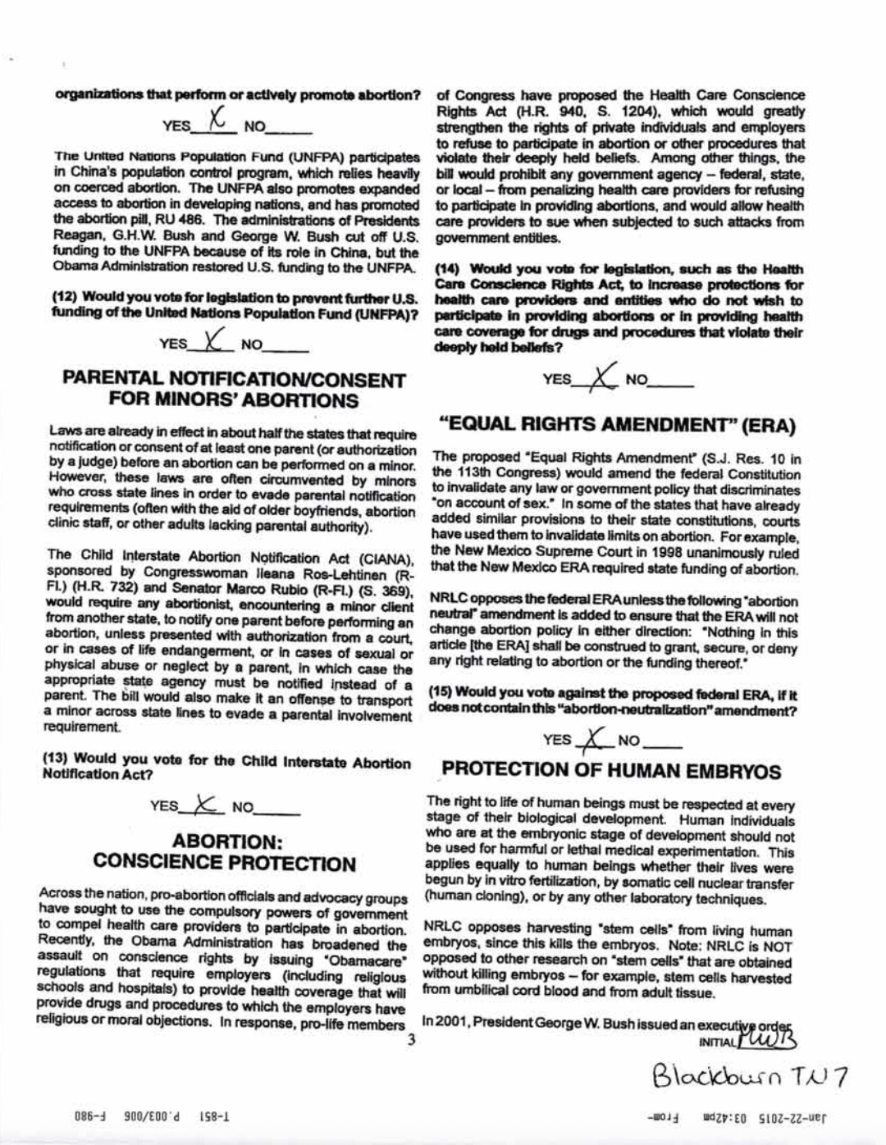

[NRLC.org, Blackburn NRLC Questionnaire 2014 (PDF), Accessed [8/21/25](https://www.nrlc.org/uploads/fedleg/BlackburnNRLCQuestionnaire2014.pdf)]

* **2014: The National Right To Life Committee’s Questionnaire Asked If The Candidate Would Vote For The Child Interstate Abortion Notification Act.**



[NRLC.org, Blackburn NRLC Questionnaire 2014 (PDF), Accessed [8/21/25](https://www.nrlc.org/uploads/fedleg/BlackburnNRLCQuestionnaire2014.pdf)]

* **2014: The National Right To Life Committee’s Questionnaire Asked If The Candidate Would Vote For Legislation That Would Increase Protections For Health Care Providers That Did Not Wish To Provide Abortions.**



[NRLC.org, Blackburn NRLC Questionnaire 2014 (PDF), Accessed [8/21/25](https://www.nrlc.org/uploads/fedleg/BlackburnNRLCQuestionnaire2014.pdf)]

* **2014: The National Right To Life Committee’s Questionnaire Asked If The Candidate Would Vote Against The Federal ERA.**



[NRLC.org, Blackburn NRLC Questionnaire 2014 (PDF), Accessed [8/21/25](https://www.nrlc.org/uploads/fedleg/BlackburnNRLCQuestionnaire2014.pdf)]

* **2014: The National Right To Life Committee’s Questionnaire Asked If The Candidate Would Vote For Legislation That Would Prevent Federal Support Of Research That Harmed Human Embryos.**

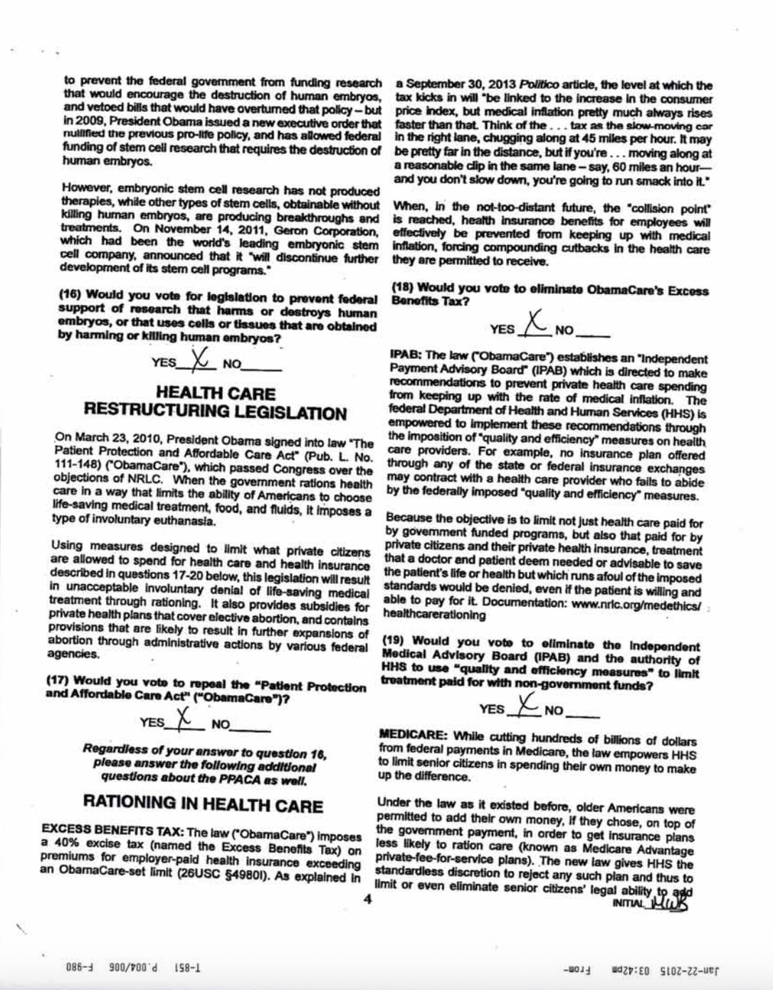

[NRLC.org, Blackburn NRLC Questionnaire 2014 (PDF), Accessed [8/21/25](https://www.nrlc.org/uploads/fedleg/BlackburnNRLCQuestionnaire2014.pdf)]

* **2014: The National Right To Life Committee’s Questionnaire Asked If The Candidate Would Vote To Repeal The ACA**.



[NRLC.org, Blackburn NRLC Questionnaire 2014 (PDF), Accessed [8/21/25](https://www.nrlc.org/uploads/fedleg/BlackburnNRLCQuestionnaire2014.pdf)]

* **2014: The National Right To Life Committee’s Questionnaire Asked If The Candidate Would Vote To Eliminate The ACA’s Excess Benefits Tax.**



[NRLC.org, Blackburn NRLC Questionnaire 2014 (PDF), Accessed [8/21/25](https://www.nrlc.org/uploads/fedleg/BlackburnNRLCQuestionnaire2014.pdf)]

* **2014: The National Right To Life Committee’s Questionnaire Asked If The Candidate Would Vote To Eliminate The Independent Medical Advisory Board And The Authority Of HHS.**



[NRLC.org, Blackburn NRLC Questionnaire 2014 (PDF), Accessed [8/21/25](https://www.nrlc.org/uploads/fedleg/BlackburnNRLCQuestionnaire2014.pdf)]

* **2014: The National Right To Life Committee’s Questionnaire Asked If The Candidate Would Vote To Restore The Previous Law So That HHS Could Not Limit Senior Citizens Rights To Choose To Add Their Money To The Medicare Payment Plan.**

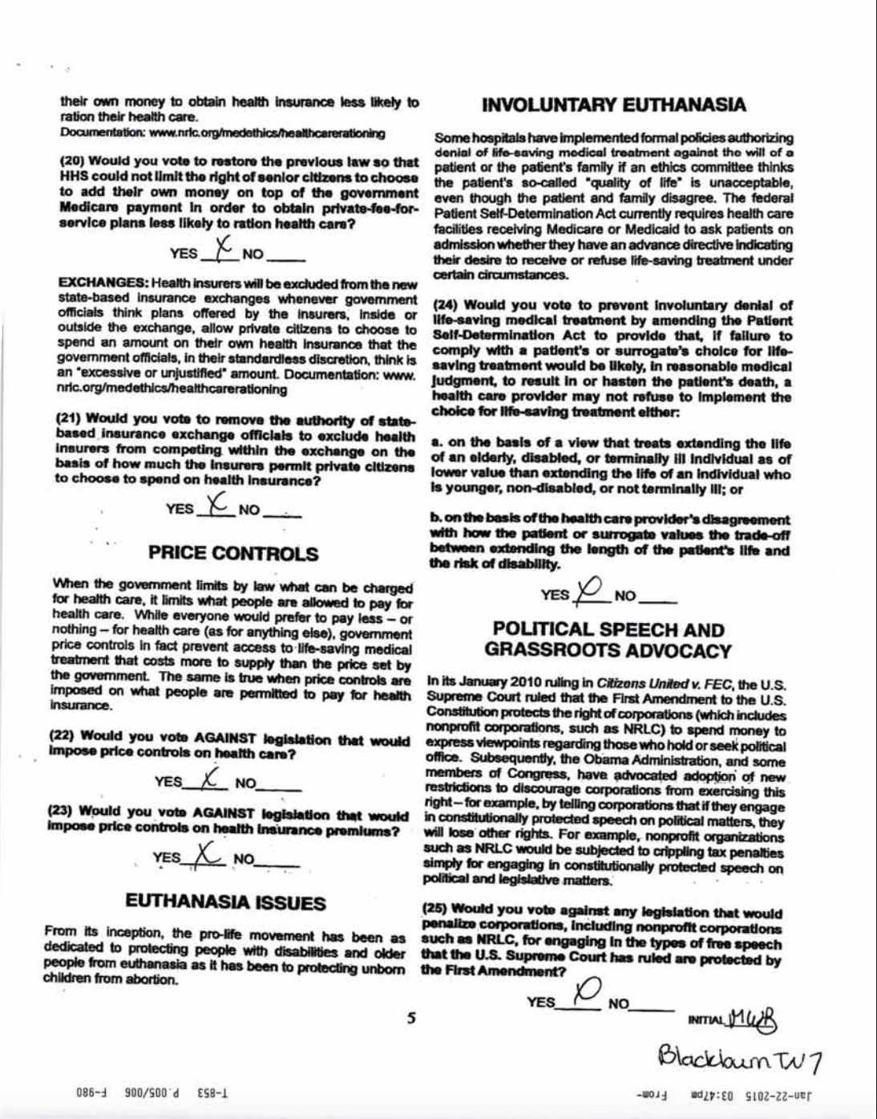

[NRLC.org, Blackburn NRLC Questionnaire 2014 (PDF), Accessed [8/21/25](https://www.nrlc.org/uploads/fedleg/BlackburnNRLCQuestionnaire2014.pdf)]

* **2014: The National Right To Life Committee’s Questionnaire Asked If The Candidate Would Vote To Remove The Authority Of State-Based Insurance Exchange Officials To Exclude Health Insurers From Competing.**



[NRLC.org, Blackburn NRLC Questionnaire 2014 (PDF), Accessed [8/21/25](https://www.nrlc.org/uploads/fedleg/BlackburnNRLCQuestionnaire2014.pdf)]

* **2014: The National Right To Life Committee’s Questionnaire Asked If The Candidate Would Vote Against Legislation That Would Impose Price Controls On Health Care.**



[NRLC.org, Blackburn NRLC Questionnaire 2014 (PDF), Accessed [8/21/25](https://www.nrlc.org/uploads/fedleg/BlackburnNRLCQuestionnaire2014.pdf)]

* **2014: The National Right To Life Committee’s Questionnaire Asked If The Candidate Would Vote Against Legislation That Would Impose Price Controls On Health Insurance Premiums.**



[NRLC.org, Blackburn NRLC Questionnaire 2014 (PDF), Accessed [8/21/25](https://www.nrlc.org/uploads/fedleg/BlackburnNRLCQuestionnaire2014.pdf)]

* **2014: The National Right To Life Committee’s Questionnaire Asked If The Candidate Would Vote Against Involuntary Euthanasia.**



[NRLC.org, Blackburn NRLC Questionnaire 2014 (PDF), Accessed [8/21/25](https://www.nrlc.org/uploads/fedleg/BlackburnNRLCQuestionnaire2014.pdf)]

* **2014: The National Right To Life Committee’s Questionnaire Asked If The Candidate Would Vote Against Penalizing Corporations For Engaging In Free Speech.**



[NRLC.org, Blackburn NRLC Questionnaire 2014 (PDF), Accessed [8/21/25](https://www.nrlc.org/uploads/fedleg/BlackburnNRLCQuestionnaire2014.pdf)]

* **2014: The National Right To Life Committee’s Questionnaire Asked If The Candidate Would Vote Against Legislation That Would Curb The Right Of Private Citizens To Support Advocacy Organizations.**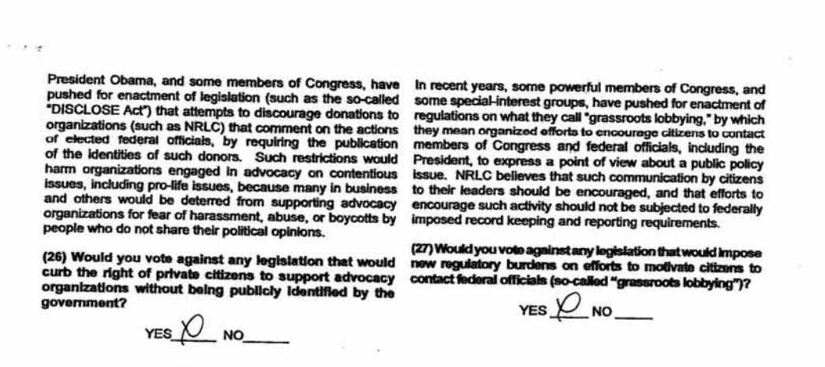

[NRLC.org, Blackburn NRLC Questionnaire 2014 (PDF), Accessed [8/21/25](https://www.nrlc.org/uploads/fedleg/BlackburnNRLCQuestionnaire2014.pdf)]

* **2014: The National Right To Life Committee’s Questionnaire Asked If The Candidate Would Vote Against Legislation That Would Impose Regulatory Burdens On Grassroots Lobbying.**

[NRLC.org, Blackburn NRLC Questionnaire 2014 (PDF), Accessed [8/21/25](https://www.nrlc.org/uploads/fedleg/BlackburnNRLCQuestionnaire2014.pdf)]

2014 – 2024: Stefanik was endorsed by the national right to life victory fund

**2024: Stefanik Was Endorsed By The National Right To Life Victory Fund.**

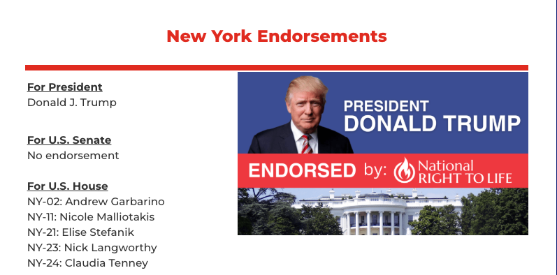

[National Right to Life Victory Fund, New York Endorsements, Archived [10/31/24](https://web.archive.org/web/20241031184056/https:/www.nrlvictoryfund.org/endorsements/newyork/)]

**2022: Stefanik Was Endorsed By The National Right To Life Victory Fund.**

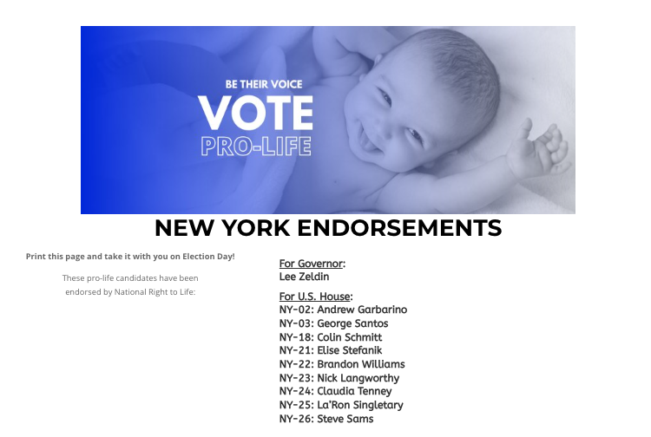

[National Right to Life Victory Fund, New York Endorsements, Archived [8/13/23](https://web.archive.org/web/20230813140605/https:/www.nrlvictoryfund.org/endorsements/newyork/)]

**2020: Stefanik Was Endorsed By The National Right To Life Victory Fund.**

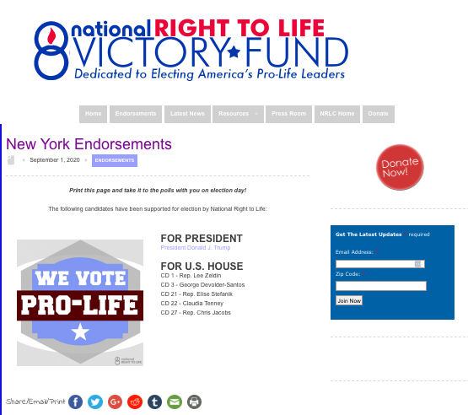

[National Right to Life Victory Fund, New York Endorsements, Archived [9/18/20](https://web.archive.org/web/20200918231339/https:/www.nrlvictoryfund.org/endorsements/newyork/)]

*NOTE: Stefanik was not endorsed by National Right to Life in 2016. It is unclear if the group backed her in 2018.*

**2014: Stefanik Was Endorsed By National Right To Life Victory Fund.**



[National Right to Life Victory Fund, 2014 New York Endorsements, Archived [9/12/15](https://web.archive.org/web/20150912101051/https:/www.nrlvictoryfund.org/endorsements/newyork2014/)]

NRA

2016

**2016: The National Rifle Association Shared An Email That Said That Stefanik Was “A” Rated And NRA-PVF Endorsed.** “Dear New York NRA Member:  Please vote Elise Stefanik for U.S. House of Representatives on Tuesday, November 8th. For more information on voting, please call 1-800-367-8683 or visit https://www.elections.ny.gov/.  Elise Stefanik, ‘A’ Rated and NRA-PVF Endorsed  The NRA Political Victory Fund (NRA-PVF) has endorsed Elise Stefanik for U.S. House of Representatives in New York’s 21st Congressional District. Elise has a proven pro-Second Amendment record and is committed to protecting your right to self-defense!” [NRA PVF, Emails, 2016, Accessed [8/21/25](https://www.nrapvf.org/emails/2016/new-york/nra-pvf-endorses-elise-stefanik-for-ny-21/)]

* **2016: The National Rifle Association Said That Stefanik Supported The Right-To-Carry And Cosponsored The Concealed Carry Reciprocity Act.** “Elise has a proven pro-Second Amendment record and is committed to protecting your right to self-defense! Supports Right-to-Carry: Cosponsor of the Concealed Carry Reciprocity Act, legislation that would ensure that law-abiding Americans with valid concealed handgun permits would be able to carry a concealed handgun in any other state that does not prohibit concealed carry.” [NRA PVF, Emails, 2016, Accessed [8/21/25](https://www.nrapvf.org/emails/2016/new-york/nra-pvf-endorses-elise-stefanik-for-ny-21/)]
* **2016: The National Rifle Association Said That Stefanik Opposed Gun Control And Creating Universal Background Checks.** “Elise has a proven pro-Second Amendment record and is committed to protecting your right to self-defense! […] Opposes Gun Control: Strongly opposes the Obama/Bloomberg/Clinton agenda of banning guns, ammunition, magazines, and creating a so-called ‘universal’ background check system that would criminalize the private transfer of firearms which, according to the Justice Department, is only enforceable through federal gun registration.” [NRA PVF, Emails, 2016, Accessed [8/21/25](https://www.nrapvf.org/emails/2016/new-york/nra-pvf-endorses-elise-stefanik-for-ny-21/)]
* **2016: The National Rifle Association Said That Stefanik Supported America’s Hunting Heritage And Voted For The Sportsmen’s Heritage And Recreation Enhancement Act.** “Elise has a proven pro-Second Amendment record and is committed to protecting your right to self-defense! […] Supports America’s Hunting Heritage: Voted for the Sportsmen’s Heritage and Recreation Enhancement Act, a bill that would benefit sportsmen throughout New York and the country.” [NRA PVF, Emails, 2016, Accessed [8/21/25](https://www.nrapvf.org/emails/2016/new-york/nra-pvf-endorses-elise-stefanik-for-ny-21/)]
* **2016: The National Rifle Association Said That Stefanik Opposed Backdoor Gun Bans.** “Elise has a proven pro-Second Amendment record and is committed to protecting your right to self-defense! […] Opposes Backdoor Gun Ban: Opposes any attempt by the Obama administration to deny millions of Social Security recipients and veterans their Second Amendment rights without due process.” [NRA PVF, Emails, 2016, Accessed [8/21/25](https://www.nrapvf.org/emails/2016/new-york/nra-pvf-endorses-elise-stefanik-for-ny-21/)]
* **2016: The National Rifle Association Said That Stefanik Voted For Legislation That Would Prohibit The Department Of Justice From Intimidating Banks Into Refusing Or Severing Financial Services With Legally-Operated Ammunition And Firearm Dealers.** “Elise has a proven pro-Second Amendment record and is committed to protecting your right to self-defense! […] Opposes Operation Choke Point: Voted for legislation that would prohibit the Obama administration from executing an abusive practice, known as Operation Choke Point, in which the Department of Justice intimidates banks into refusing or severing financial services to legally-operated ammunition and firearms dealers.” [NRA PVF, Emails, 2016, Accessed [8/21/25](https://www.nrapvf.org/emails/2016/new-york/nra-pvf-endorses-elise-stefanik-for-ny-21/)]
* **2016: The National Rifle Association Said That Stefanik Opposed Any Ban On Semi-Automatic Firearms.** “Elise has a proven pro-Second Amendment record and is committed to protecting your right to self-defense! […] Opposes Semi-auto Ban: Opposes any ban on commonly owned semi-automatic firearms used for hunting, recreational shooting and self-defense.” [NRA PVF, Emails, 2016, Accessed [8/21/25](https://www.nrapvf.org/emails/2016/new-york/nra-pvf-endorses-elise-stefanik-for-ny-21/)]

**2016: The National Rifle Association Said That Stefanik’s Opponent Refused To Answer Questions About The Second Amendment.** “In contrast, her opponent, Mike Derrick, has received a ‘?’ rating from NRA-PVF. He refused to answer the most basic questions regarding the Second Amendment and our fundamental right of self-defense. For this reason, he cannot be trusted to stand up to President Obama, Hillary Clinton and former New York City Mayor Michael Bloomberg’s gun control agenda.” [NRA PVF, Emails, 2016, Accessed [8/21/25](https://www.nrapvf.org/emails/2016/new-york/nra-pvf-endorses-elise-stefanik-for-ny-21/)]

2016 – 2024: Stefanik was endorsed by the national rifle association

**2024: Stefanik Was Endorsed By The National Rifle Association.**

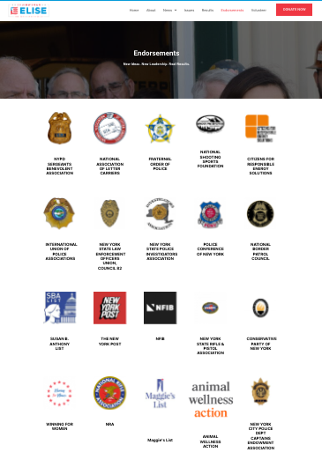

[Elise for Congress, Endorsements, Archived [11/12/24](https://web.archive.org/web/20241112122444/https:/eliseforcongress.com/endorsements/)]

**2022:** **Stefanik Was Endorsed By The National Rifle Association.**

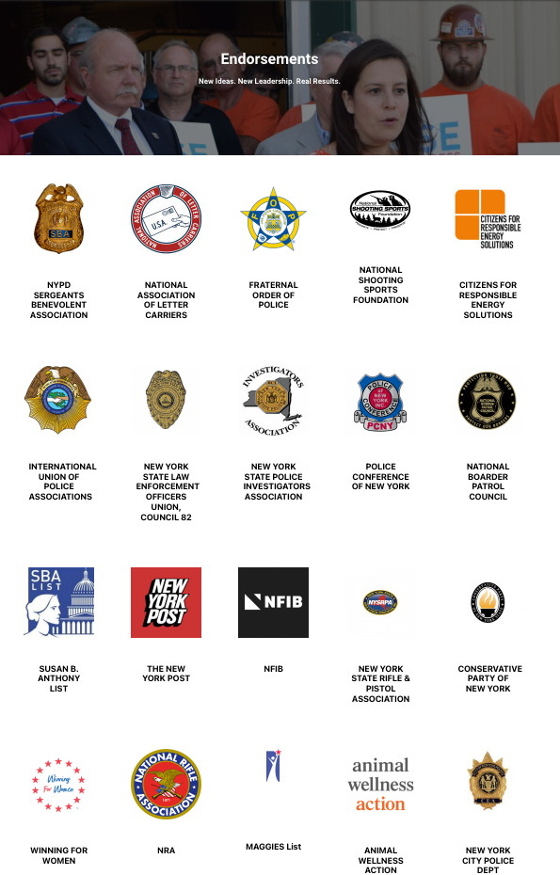

[Elise for Congress, Endorsements, Archived [11/9/22](https://web.archive.org/web/20221109100917/https:/eliseforcongress.com/endorsements/)]

**2020:** **Stefanik Was Endorsed By The National Rifle Association.**

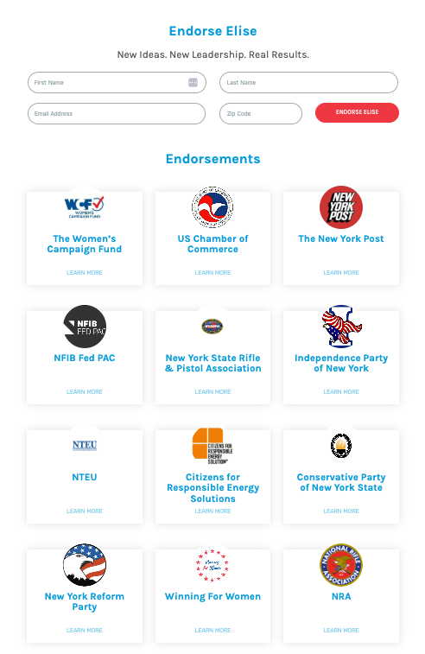

[Elise for Congress, Endorsements, Archived [2/17/20](https://web.archive.org/web/20200217161615/https:/eliseforcongress.com/endorsements/)]

**2018:** **Stefanik Was Endorsed By The National Rifle Association.**

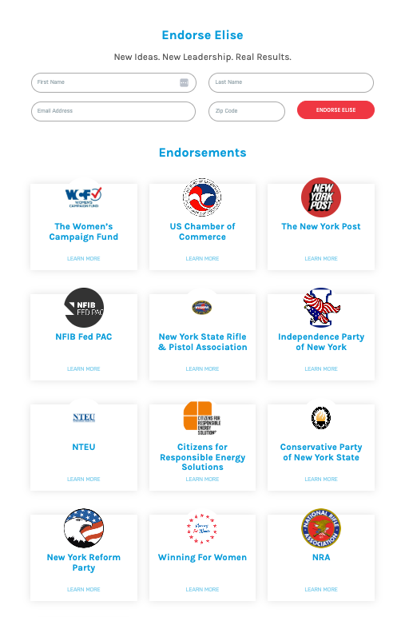

[Elise for Congress, Endorsements, Archived [11/6/18](https://web.archive.org/web/20181106171951/eliseforcongress.com/endorsements/)]

**2016: The National Rifle Association Shared An Email That Said That Stefanik Was “A” Rated And NRA-PVF Endorsed.** “Dear New York NRA Member:  Please vote Elise Stefanik for U.S. House of Representatives on Tuesday, November 8th. For more information on voting, please call 1-800-367-8683 or visit https://www.elections.ny.gov/.  Elise Stefanik, ‘A’ Rated and NRA-PVF Endorsed  The NRA Political Victory Fund (NRA-PVF) has endorsed Elise Stefanik for U.S. House of Representatives in New York’s 21st Congressional District. Elise has a proven pro-Second Amendment record and is committed to protecting your right to self-defense!” [NRA PVF, Emails, 2016, Accessed [8/21/25](https://www.nrapvf.org/emails/2016/new-york/nra-pvf-endorses-elise-stefanik-for-ny-21/)]

METHODOLOGY

ABORTION

SUSAN B. ANTHONY LIST

Stefanik endorsements:

* [2025](https://eliseforcongress.com/endorsements/): Stefanik was endorsed by Susan B. Anthony List
* [2024](https://web.archive.org/web/20241112122444/https:/eliseforcongress.com/endorsements/): Stefanik was endorsed by Susan B. Anthony List
* [2023-2024](https://sbaprolife.org/representative/elise-stefanik): Stefanik received an A+ rating from Susan B. Anthony List
  + [2023](https://stefanik.house.gov/2023/1/stefanik-earns-a-rating-for-protecting-life): Stefanik received an A+ rating from Susan B. Anthony List
* [2022](https://web.archive.org/web/20221109100917/https:/eliseforcongress.com/endorsements/): Stefanik was endorsed by Susan B. Anthony List
* [2021-2022](https://sbaprolife.org/representative/elise-stefanik): Stefanik received an A+ rating from Susan B. Anthony List
* [2021](https://web.archive.org/web/20210913221559/https:/eliseforcongress.com/endorsements-page/): Stefanik was endorsed by Susan B. Anthony List
* [2019-2021](https://sbaprolife.org/representative/elise-stefanik): Stefanik received a B rating from Susan B. Anthony List
* [2014](https://web.archive.org/web/20141105183709/https:/eliseforcongress.com/endorsements/): Stefanik was endorsed by Susan B. Anthony List

Information on endorsement:

* The Susan B. Anthony List requires a questionnaire to be considered for an endorsement

Located questionnaires: Unable to locate questionnaires

NATIONAL RIGHT TO LIFE COMMITTEE

Stefanik endorsements:

* [2025](https://www.nrlvictoryfund.org/endorsements/newyork/): Stefanik was endorsed by National Right to Life Victory Fund
* [2024](https://web.archive.org/web/20241031184056/https:/www.nrlvictoryfund.org/endorsements/newyork/): Stefanik was endorsed by National Right to Life Victory Fund
* [2022](https://web.archive.org/web/20230813140605/https:/www.nrlvictoryfund.org/endorsements/newyork/): Stefanik was endorsed by National Right to Life Victory Fund
* [2020](https://web.archive.org/web/20200918231339/https:/www.nrlvictoryfund.org/endorsements/newyork/): Stefanik was endorsed by National Right to Life Victory Fund
* [2015](https://nrlc.org/wp-content/uploads/2024/02/NRLNewsJan2015.pdf): Stefanik was supported by National Right to Life Victory Fund
* [2014](https://web.archive.org/web/20150912101051/https:/www.nrlvictoryfund.org/endorsements/newyork2014/): Stefanik was endorsed by National Right to Life Victory Fund

Information on endorsement:

* The National Right to Life Victory Fund requires an application as part of the endorsement consideration process

Located Questionnaires:

* [2022](https://x.com/AngieCraigMN/status/1584936852074639360): Congressional Candidate Questionnaire
* [2014](https://www.nrlc.org/uploads/fedleg/BlackburnNRLCQuestionnaire2014.pdf): Marsha Blackburn Questionnaire – Stefanik may have filled out this questionnaire

*\*Note: Has been backed up to the Wayback Machine.*

NEW YORK STATE RIGHT TO LIFE

Stefanik endorsements:

* [2025](https://eliseforcongress.com/endorsements/): Stefanik was endorsed by New York State Right to Life
* [2024](https://web.archive.org/web/20241112122444/https:/eliseforcongress.com/endorsements/): Stefanik was endorsed by New York State Right to Life

Information on endorsement:

* NYS Right to Life requires a questionnaire to be considered for an endorsement

Located questionnaires: Unable to locate questionnaires

FAITH AND FREEDOM COALITION

Stefanik endorsements:

* [2024](https://www.ffcoalition.com/elise-stefanik-to-address-faith-freedom-coalitions-road-to-majority-policy-conference-2024/): Stefanik spoke at an event for the Faith & Freedom Coalition
  + Speech found [here](https://stefanik.house.gov/2024/6/stefanik-receives-the-ronald-reagan-defender-of-freedom-award-addresses-faith-and-freedom-coalition-conference)
* [2024](https://www.youtube.com/watch?v=YQ-JTcyOSCc): The Faith & Freedom Coalition released a video highlighting Stefanik’s work
* [2024](https://stefanik.house.gov/2024/6/stefanik-receives-the-ronald-reagan-defender-of-freedom-award-addresses-faith-and-freedom-coalition-conference): Stefanik received the Ronald Reagan Defender of Freedom Award from the Faith & Freedom Coalition

Information on endorsement:

* Faith and Freedom Coalition requires a questionnaire to be considered for an endorsement

Located questionnaires: Unable to locate questionnaires

CONSERVATIVE PARTY OF NEW YORK STATE

Stefanik endorsements:

* [2024](https://web.archive.org/web/20241112122444/https:/eliseforcongress.com/endorsements/): Stefanik was endorsed by the Conservative Party of New York State
* [2022](https://web.archive.org/web/20221109100917/https:/eliseforcongress.com/endorsements/): Stefanik was endorsed by the Conservative Party of New York State
* [2021](https://web.archive.org/web/20210913221559/https:/eliseforcongress.com/endorsements-page/): Stefanik was endorsed by the Conservative Party of New York State
* [2020](https://web.archive.org/web/20200217161615/https:/eliseforcongress.com/endorsements/): Stefanik was endorsed by the Conservative Party of New York State
* [2018](https://web.archive.org/web/20181106171951/https:/eliseforcongress.com/endorsements/): Stefanik was endorsed by the Conservative Party of New York State
* [2014](https://web.archive.org/web/20141105183709/https:/eliseforcongress.com/endorsements/): Stefanik was endorsed by the Conservative Party of New York State

Organization position:

* [As of 2025](https://www.cpnys.org/legislative-priorities/): The CPNYS opposes taxpayer dollars spent on abortion

Information on endorsement:

* No information indicating they require a questionnaire

Located questionnaires: Unable to locate questionnaires

GUNS

NEW YORK STATE RIFLE & PISTOL ASSOCIATION

Stefanik endorsements:

* [2025](https://eliseforcongress.com/endorsements/): Stefanik was endorsed by the New York State Rifle & Pistol Association
* [2024](https://web.archive.org/web/20241112122444/https:/eliseforcongress.com/endorsements/): Stefanik was endorsed by the New York State Rifle & Pistol Association
* [2022](https://web.archive.org/web/20221109100917/https:/eliseforcongress.com/endorsements/): Stefanik was endorsed by the New York State Rifle & Pistol Association
* [2020](https://web.archive.org/web/20200217161615/https:/eliseforcongress.com/endorsements/): Stefanik was endorsed by the New York State Rifle & Pistol Association
* [2018](https://web.archive.org/web/20181106171951/https:/eliseforcongress.com/endorsements/): Stefanik was endorsed by the New York State Rifle & Pistol Association

Information on endorsement:

* Requires a questionnaire

Located Questionnaire: Unable to locate

NEW YORK STATE FIREARMS ASSOCIATION

No proof that Stefanik was ever endorsed by this group. If she was, they posted the questionnaire

Located questionnaires:

* [2024](https://www.newyorkstatefirearmsassociation.org/elections/) Questionnaire

*\*Note: Has been backed up to the Wayback Machine.*

NRA

Stefanik endorsements:

* [2025](https://eliseforcongress.com/endorsements/): Stefanik was endorsed by the NRA
* [2024](https://web.archive.org/web/20241112122444/https:/eliseforcongress.com/endorsements/): Stefanik was endorsed by the NRA
* [2022](https://web.archive.org/web/20221109100917/https:/eliseforcongress.com/endorsements/): Stefanik was endorsed by the NRA
* [2021](https://web.archive.org/web/20210913221559/https:/eliseforcongress.com/endorsements-page/): Stefanik was endorsed by the NRA
* [2020](https://web.archive.org/web/20200217161615/https:/eliseforcongress.com/endorsements/): Stefanik was endorsed by the NRA
* [2018](https://web.archive.org/web/20181106171951/https:/eliseforcongress.com/endorsements/): Stefanik was endorsed by the NRA

Information on endorsement:

* Requires a questionnaire

Located questionnaires:

* [2016](https://www.nrapvf.org/emails/2016/new-york/nra-pvf-endorses-elise-stefanik-for-ny-21/) Email that lists why the NRA endorsed Stefanik

NEW YORK REFORM PARTY

Stefanik endorsements:

* [2020](https://web.archive.org/web/20200217161615/https:/eliseforcongress.com/endorsements/): Stefanik was endorsed by the New York Reform Party
* [2018](https://web.archive.org/web/20181106171951/https:/eliseforcongress.com/endorsements/): Stefanik was endorsed by the New York Reform Party
  + The New York Reform Party supported the Second Amendment and opposed the NY SAFE Act

Information on endorsement:

* No clear answer

Located questionnaires: Unable to locate questionnaires

SEARCHES

* Searched Perplexity to compile a list of groups that endorsed Stefanik
* Searched Stefanik’s campaign site & archived site for endorsements
* Searched Perplexity to ask what endorsements required a questionnaire
* Searched Perplexity to determine what groups published questionnaires
* Completed a Google site search for the following:
  + site: nrlvictoryfund.org “stefanik” AND (“questionnaire” OR “response”)
  + site: nrlvictoryfund.org ("application" AND "Endorsement")
  + “questionnaire” AND (“national right to life”)
  + site:sbaprolife.org ("questionnaire")
  + (“questionnaire” OR “application”) AND (“susan b. Anthony” OR “SBA Pro”)
  + sitenysrighttolife.org ("questionnaire" OR "application")
  + ("new york state right to life" OR "NY right to life" OR "NYS right to life") AND "questionnaire"
  + “questionnaire” AND (“national right to life”)
  + “questionnaire” AND (“right to life”)
  + site:ffcoalition.com "questionnaire"
  + "faith and freedom coalition" AND "questionnaire" AND "stefanik"
  + "faith and freedom coalition" AND "questionnaire"
  + site:cpnys.org ("questionnaire" OR "responsore" OR "application")
  + "conservative party of new york state" AND "questionnaire"
  + site:nysrpa.org "questionnaire"
  + Site: nysrpa.org "stefanik”
  + site:newyorkstatefirearmsassociation.org "stefanik"
  + site:newyorkstatefirearmsassociation.org ("questionnaire" OR "application")
  + (“new York state rifle and pistol association” OR “new York state firearms association”) AND (“questionnaire”)
  + site:nrapvf.org "questionnaire"
  + site:nrapvf.org "stefanik"
  + “NRA” AND “questionnaire”
  + "NRA" AND "New york" AND "questionnaire"
  + site:reformpartyny.org "questionnaire"
  + site:reformpartyny.org "stefanik"
  + site:reformpartyny.org "questionnaire"
  + “New york” AND “reform party” AND “questionnaire”
* Advanced Twitter media searches
  + “susan b. Anthony” questionnaire
  + “SBA” questionnaire
  + “right to life” “questionnaire”
  + “new York state right to life” AND questionnaire
  + “faith and freedom coalition” “questionnaire”
  + “new york state firearms” “questionnaire”
  + ("NRA" OR "national rifle association") AND "questionnaire" AND ("New york" OR "NY")
  + “NRA” “questionnaire” – media search
  + “national rifle association” “questionnaire” – media search